# Setting up Study Group email in Outlook 2013 and beyond

This document is designed to guide you through the steps needed to attach Study Group email through Outlook 2013 and later.

1. Open Control Panel   
   In Windows 7, Click **Start**, choose **Control Panel**  
   In Windows 10, **Right-click Start** and choose **Control Panel**
2. In the top right, in the **View** section, choose **Small icons**
3. Open “**Mail**”
4. Click **Email Accounts**
5. Choose **New**
6. Type your name and our email address in the fields and click next.
7. A security prompt should appear.  
   Choose “**More choices**”  
   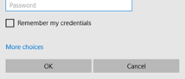  
   Choose “**Use a different account**”  
   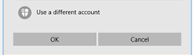
8. In the **username** field type **STAFF\** and your username eg: STAFF\jbloggs
9. Type your Study Group password and tick the box marked “**remember my credentials**”
10. Click **OK**.
11. Click **Finish**

When you open Outlook next, it *may* ask you for your credentials again. Remember that you may need to follow Steps 7 – 10 to make sure the right information is entered.